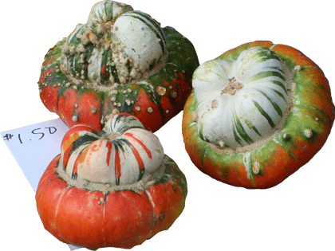
Charlotte's Web Site
555 Main Street
Brighton, MI 48116
Is Pleased to Invite
«FirstName» «LastName»
To Our Open House
Nov. 7th, 2011
From 1:00 PM – 5:00 PM

