Charlotte’s Website
Q3 2011
Elizabeth
Charlotte’s Website
Q3 2011

From the Farm to Your Table: That’s Fresh!
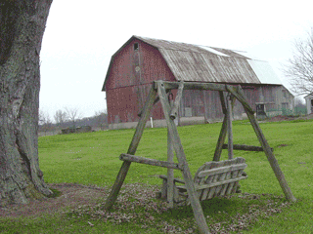
Charlotte's Web Site
123 Main Street
Brighton MI 48116
Friday, August 20, 2010

Dear Friends and Clients,

Welcome to Charlotte's Website. Our “Farm Fresh” approach has been profitable this year. This Quarterly Report –focuses on our - product sales and our new product releases.

Sincerely,
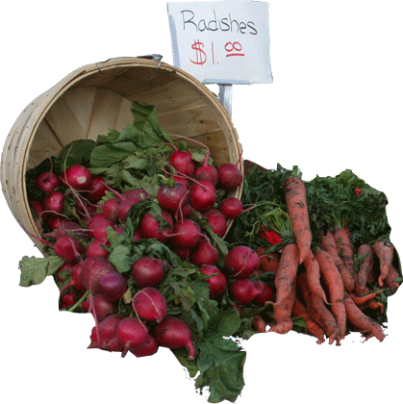
Elizabeth

Products In Stock
- Apples, Fruit, 25
- Bananas, Fruit, 12
- Kiwi, Fruit, 14
- Peppers, Veggie, 50
- Tomato, Fruit, 10
  - Roma
  - Better Boy

Sample Heading
Lorem ipsum dolor sit amet, consectetur adipisicing elit, sed do eiusmod tempor incididunt ut labore et dolore magna aliqua. Ut enim ad minim veniam, quis nostrud exercitation ullamco laboris nisi ut aliquip ex ea commodo consequat. Duis aute irure dolor in reprehenderit in voluptate velit esse cillum dolore eu fugiat nulla pariatur. Excepteur sint occaecat cupidatat non proident, sunt in culpa qui officia deserunt mollit anim id est laborum

Sample Heading
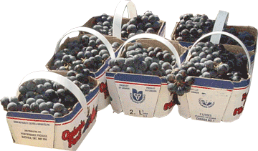
Lorem ipsum dolor sit amet, consectetur adipisicing elit, sed do eiusmod tempor incididunt ut labore et dolore magna aliqua. Ut enim ad minim veniam, quis nostrud exercitation ullamco laboris nisi ut aliquip ex ea commodo consequat. Duis aute irure dolor in reprehenderit in voluptate velit esse cillum dolore eu fugiat nulla pariatur. Excepteur sint occaecat cupidatat non proident, sunt in culpa qui officia deserunt mollit anim id est laborum

Fresh Fruits
Apples
Avocados
Kiwis
Pears
Fresh Vegetables
Chives
Tomatoes

